**DAILY ONLINE ACTIVITIES SUMMARY**

|  |  |  |  |  |  |  |  |
| --- | --- | --- | --- | --- | --- | --- | --- |
| **Date:** | **23-06-2020** | | | | **Name:** | **B.A.SOHANKUMAR** | |
| **Sem & Sec** | **4TH SEM A** | | | | **USN:** | **4AL18CS013** | |
| **Online Test Summary** | | | | | | | |
| **Subject** | | **----** | | | | | |
| **Max. Marks** | | **----** | | **Score** | | **----** | |
| **Certification Course Summary** | | | | | | | |
| **Course** | **CLOUD COMPUTING WITH AWS** | | | | | | |
| **Certificate Provider** | | | **GLA** | **Duration** | | | **12 HOURS** |
| **Coding Challenges** | | | | | | | |
| **Problem Statement: Java program to sort a stack using temporary stack.** | | | | | | | |
| **Status: EXECUTED** | | | | | | | |
| **Uploaded the report in Github** | | | | **YES** | | | |
| **If yes Repository name** | | | | **LOCKDOWN CODING** | | | |
| **Uploaded the report in slack** | | | | **YES** | | | |

**CERTIFICATION COURSE DETAILS:**

Course:cloud computing with aws

Completed modules today are Networking on AWS Overview,Module 14 - Overview of Virtual Private Cloud - VPC,Module 15 - Hybrid Cloud & Networking,Module 16 - Walk-through AWS VPC Console,Module 17 - Creating & Using VPC - A Step by Step Use Case,Module 18 - VPC Peering,Module 19 - VPC EndPoints, Services & Route 53,New – VPC Endpoint for Amazon S3,Module 20 - Route 53 Demo.

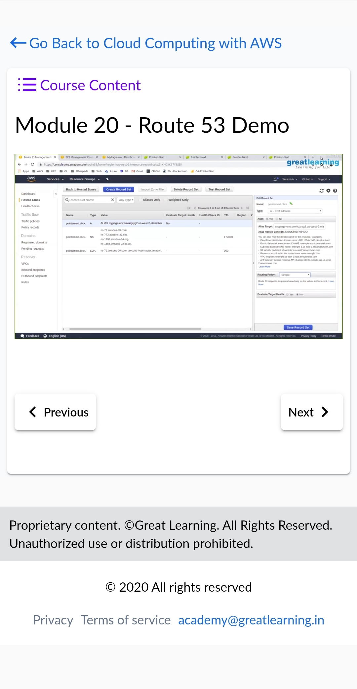 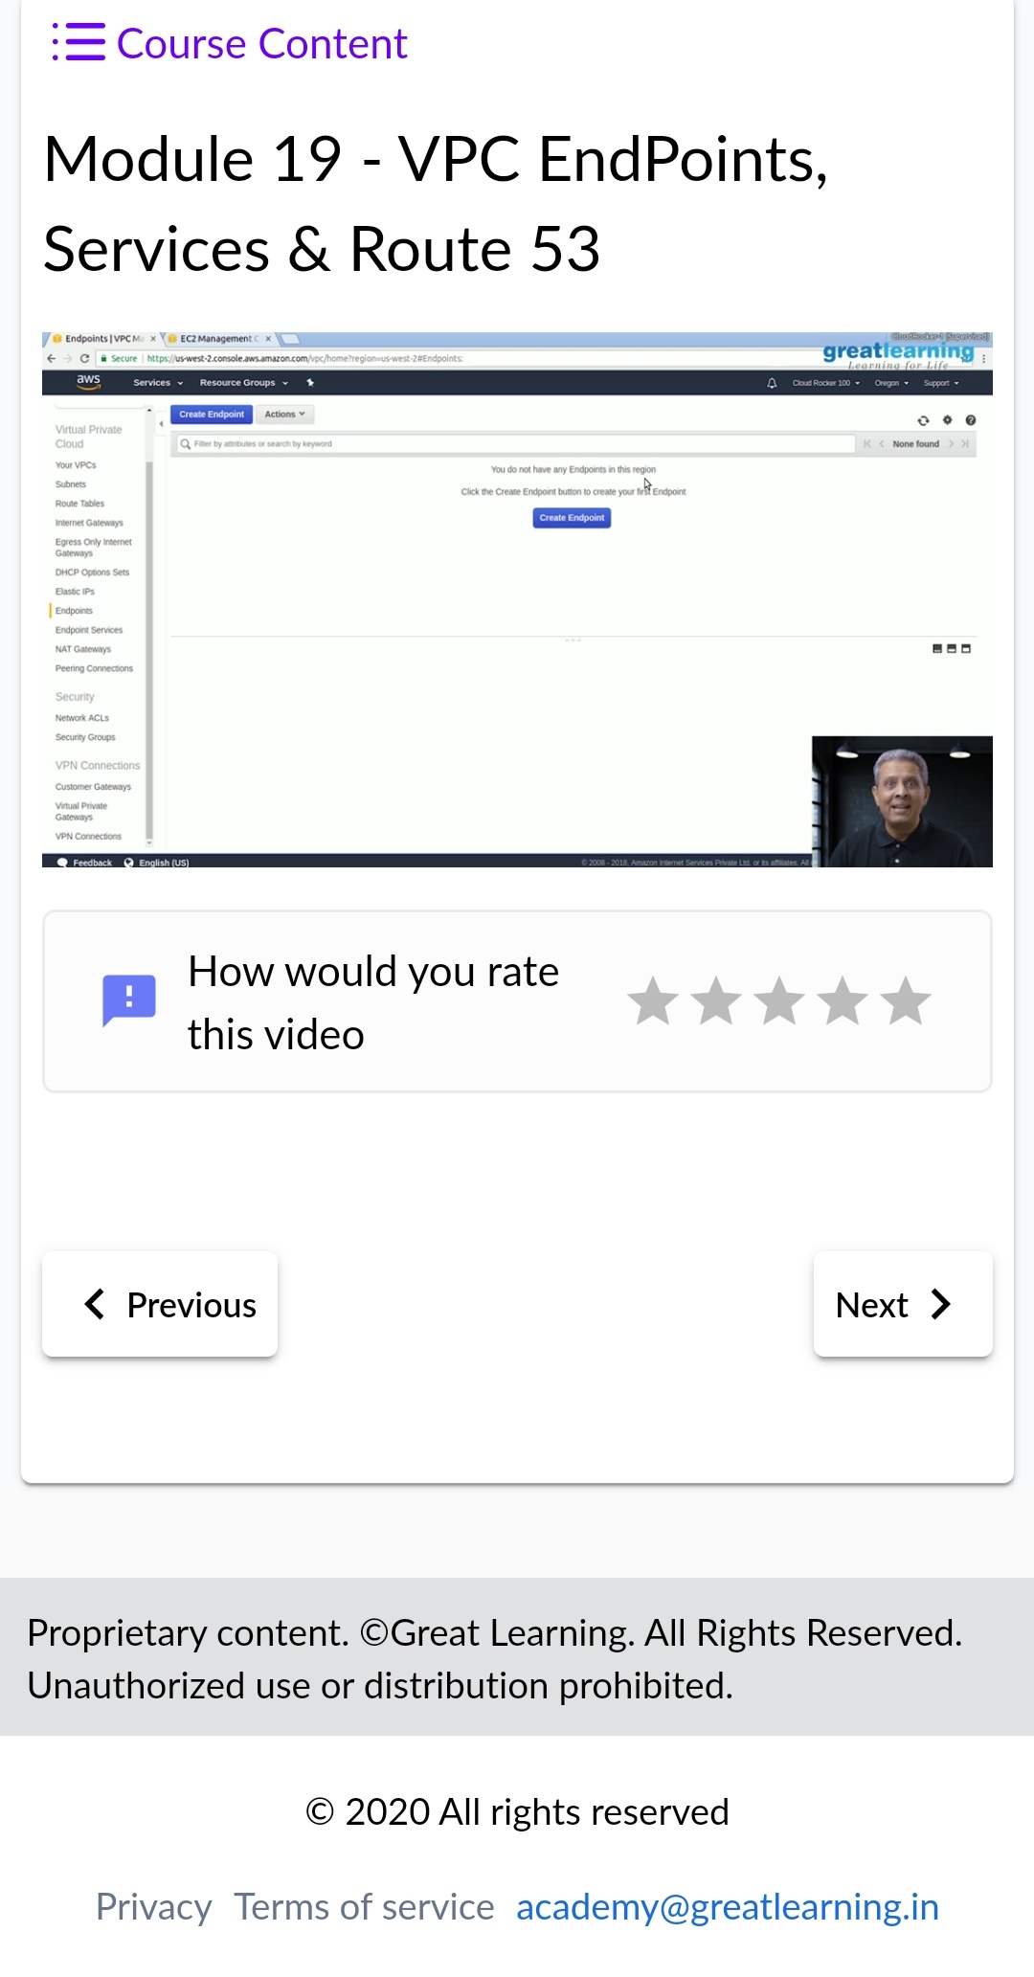

**CODING CHALLENGES DETAILS:**

1.Write a java Program to Sort a stack using a temporary stack .

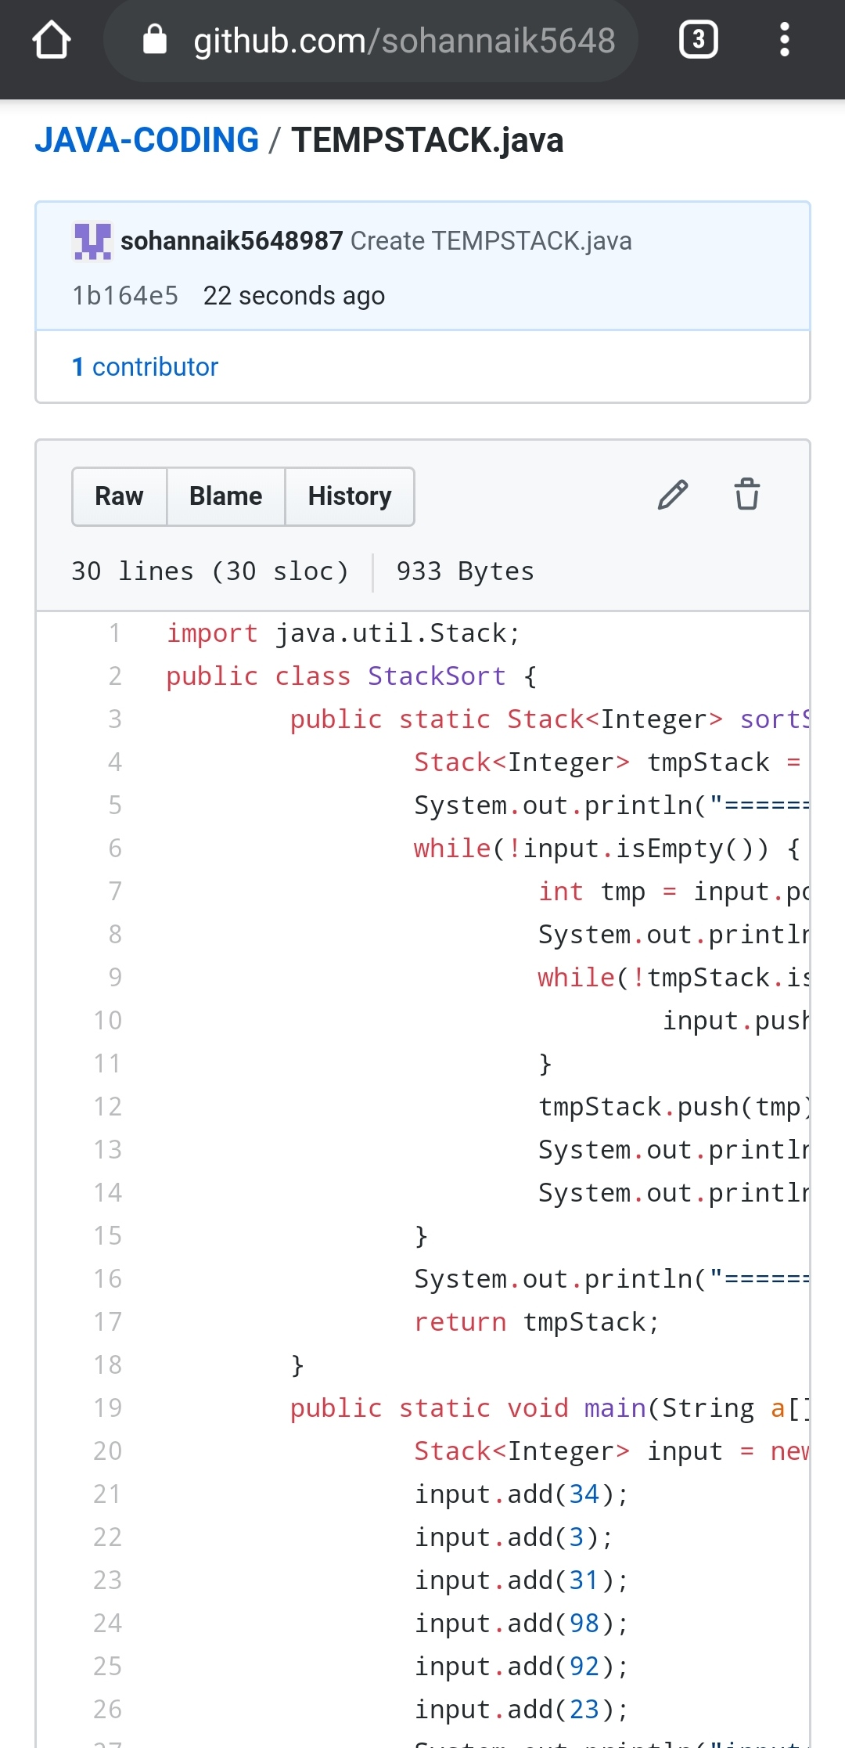

REPOSITORY LINK:https://github.com/sohannaik5648987/JAVA-CODING